**INVENTORY MANAGEMENT SYSTEM FOR RETAILERS**

**Developed by: Pratiksha Jayesh Bongale**

**SmartBridge-VMware Build-A-Thon**

**1. INDRODUCTION**

[Inventory management](https://www.investopedia.com/articles/investing/020116/how-analyze-companys-inventory.asp) refers to the process of ordering, storing and using a company's inventory. This includes the management of raw materials, components and finished products, as well as warehousing and processing such items.

For companies with complex supply chains and manufacturing processes, balancing the risks of inventory gluts and shortages is especially difficult. To achieve these balances, firms have developed two major methods for inventory management: [just-in-time (JIT)](https://www.investopedia.com/terms/j/jit.asp) and [materials requirement planning (MRP)](https://www.investopedia.com/terms/m/mrp.asp).

A company's [inventory](https://www.investopedia.com/terms/g/gmroi.asp) is one of its most valuable assets. In retail, manufacturing, food service and other inventory-intensive sectors, a company's inputs and finished products are the core of its business. A shortage of inventory when and where it's needed can be extremely detrimental.

At the same time, inventory can be thought of as a liability (if not in an accounting sense). A large inventory carries the risk of spoilage, theft, damage or shifts in demand. Inventory must be insured, and if it is not sold in time it may have to be disposed of at clearance prices—or simply destroyed.

For these reasons, inventory management is important for businesses of any size. Knowing when to restock inventory, what amounts to purchase or produce, what price to pay—as well as [when to sell](https://www.investopedia.com/articles/stocks/10/when-to-sell-stocks.asp) and at what price—can easily become complex decisions. Small businesses will often keep track of stock manually and determine the reorder points and quantities using Excel formulas. Larger businesses will use specialized [enterprise resource planning (ERP)](https://www.investopedia.com/terms/e/erp.asp) software. The largest corporations use highly customized [software as a service (SaaS)](https://www.investopedia.com/terms/s/software-as-a-service-saas.asp) applications.

Appropriate inventory management strategies vary depending on the industry. An oil depot is able to store large amounts of inventory for extended periods of time, allowing it to wait for demand to pick up. While storing oil is expensive and risky—a [fire in the UK in 2005](https://www.bbc.com/news/uk-10266706) led to millions of pounds in damage and fines—there is no risk that the inventory will spoil or go out of style. For businesses dealing in perishable goods or products for which demand is extremely time-sensitive—2019 calendars or fast-fashion items, for example—sitting on inventory is not an option, and misjudging the timing or quantities of orders can be costly.

### KEY TAKEAWAYS

* Inventory management refers to the process of ordering, storing and using a company's inventory. This includes the management of raw materials, components and finished products, as well as warehousing and processing such items.
* For companies with complex supply chains and manufacturing processes, balancing the risks of inventory gluts and shortages is especially difficult.
* To achieve these balances, firms have developed two major methods for inventory management: just-in-time (JIT) and materials requirement planning (MRP).

## Inventory Accounting

Inventory represents a [current asset](https://www.investopedia.com/terms/c/currentassets.asp) since a company typically intends to sell its finished goods within a short amount of time, typically a year. Inventory has to be physically counted or measured before it can be put on a balance sheet. Companies typically maintain sophisticated [inventory management systems](https://www.investopedia.com/best-inventory-management-software-5088863) capable of tracking real-time inventory levels. Inventory is accounted for using one of three methods: [first-in-first-out (FIFO)](https://www.investopedia.com/terms/f/fifo.asp) costing; [last-in-first-out (LIFO)](https://www.investopedia.com/terms/l/lifo.asp) costing; or [weighted-average costing](https://www.investopedia.com/ask/answers/09/weighted-average-fifo-lilo-accounting.asp).

An inventory account typically consists of four separate categories:

1. [Raw materials](https://www.investopedia.com/terms/r/rawmaterials.asp)
2. Work in process
3. Finished goods
4. Merchandise

Raw materials represent various materials a company purchases for its production process. These materials must undergo significant work before a company can transform them into a finished good ready for sale.

Works-in-process represent raw materials in the process of being transformed into a finished product. Finished goods are completed products readily available for sale to a company's customers. Merchandise represents finished goods a company buys from a supplier for future resale.

**Overview**

As a part of your supply chain, inventory management includes aspects such as controlling and overseeing purchases — from suppliers as well as customers — maintaining the storage of stock, controlling the amount of product for sale, and order fulfilment. Naturally, your company’s precise inventory management meaning will vary based on the types of products you sell and the channels you sell them through. But as long as those basic ingredients are present, you’ll have a solid foundation to build upon. [Small-to-medium businesses (SMBs)](https://www.tradegecko.com/learning-center/small-business-inventory-management-introduction?hsLang=en-us) often use Excel, Google Sheets, or other manual tools to keep track of inventory databases and make decisions about ordering. We try to build an Inventory Management System for retailers to keep track of their inventory by allowing them to insert, update, delete items and much more. It also sends them an email upon new registration and when the stock empties.A Flask application is also built for the ease of use. The app has been mordenized using docker, a docker image has been created and the same has been deployed onto vmware’s tanzu service for everyone to use.

**Purpose**

Our aim from the project is to make use of python, sendgrid, docker, vmware tanzu, flask. Secondly, to make an easy-to-use IMS system that can be accessed from anywhere and at anytime.

**2. LITERATURE SURVEY**

For any goods-based businesses, the [value of inventory](https://www.tradegecko.com/learning-center/inventory-valuation-methods?hsLang=en-us) cannot be overstated, which is why inventory management benefits your operational efficiency and longevity.

From SMBs to companies already using [enterprise resource planning](https://www.tradegecko.com/inventory-management/what-is-erp-inventory-management?hsLang=en-us) (ERP), without a smart approach, you’ll face an army of challenges, including blown-out costs, loss of profits, poor customer service, and even outright failure.

**2.1 Existing Problem**

The previous models have high time complexity and space complexity model is constrained with the lot of advantages and with the ease-of-use than any other system already proposed.

Manual inventory management practices such as using Excel is usually the first tool small-to-medium sized businesses use to manage their inventory. While spreadsheets and the likes work fine in the beginning when you’re a small operation, they can quickly lead to crippling issues.

In the same way, manual inventory tracking and stocktaking can be suitable for small businesses but again become time-consuming and erroneous as your company grows. Not only does this impact your businesses ability to foster growth, data errors can have snowballing effects.

Large volumes of inventory can lead to management nightmares as they can cut into your profits. Most businesses have 20 to 40% of their working capital tied up in inventory stock. Inventory reduction is difficult to do, but it is essential if you want to go from poor inventory management to great inventory control and management. [Here’s how you can reduce your stock](https://www.unleashedsoftware.com/blog/3-steps-help-reduce-inventory-maximize-profitability).

If you are not using accurate data to identify sales trend, best-selling items, customer behaviour and more, you’ll either order too much and experience [the problems of excess inventory stock](https://www.unleashedsoftware.com/blog/excess-inventory-carrying-costs-make-inventory-excess-bad-business-decision), or order too little and experience stockouts and lost customers. With accurate reports, you can better forecast your customers future behaviour and order accordingly to meet customer demand.

**2.2 Proposed Solution**

In this system we try to build an Inventory Management System for retailers to keep track of their inventory by allowing them to insert, update, delete items and much more. It also sends them an email upon new registration and when the stock empties.A Flask application is also built for the ease of use. The app has been mordenized using docker, a docker image has been created and the same has been deployed onto vmware’s tanzu service for everyone to use.

**3. THEORETICAL ANALYSIS**

Retail inventory management is the process of ensuring you carry merchandise that shoppers want, with neither too little nor too much on hand. By managing inventory, retailers meet customer demand without running out of stock or carrying excess supply.

In practice, effective retail inventory management results in lower costs and a better understanding of sales patterns. Retail inventory management tools and methods give retailers more information with which to run their businesses. Applications have been developed to help retailers to track and manage stocks related to their own products. The System will ask retailers to create their account by providing essential details. Retailers can access their accounts by logging to the application.

Once retailers successfully login to the application they can update their inventory details, also users will be able to add new stock by submitting essential details related to the stock. They can view details of the current inventory. The System will automatically send an email alert to the retailers if there is no stock found in their account. So that they can order new stock.

**3.1 Block Diagram**

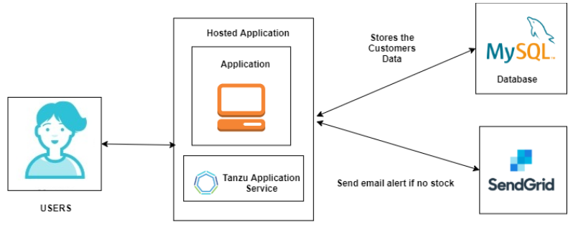

**3.2 Software Designing**

* Spyder IDE
* Python
* Flask
* HTML
* CSS, Bootstrap
* Docker
* VMware Tanzu Service

In this system we try to build an Inventory Management System for retailers to keep track of their inventory by allowing them to insert, update, delete items and much more. It also sends them an email upon new registration and when the stock empties.A Flask application is also built for the ease of use. The app has been mordenized using docker, a docker image has been created and the same has been deployed onto vmware’s tanzu service for everyone to use.

**4. RESULT**

1. **Home Page**

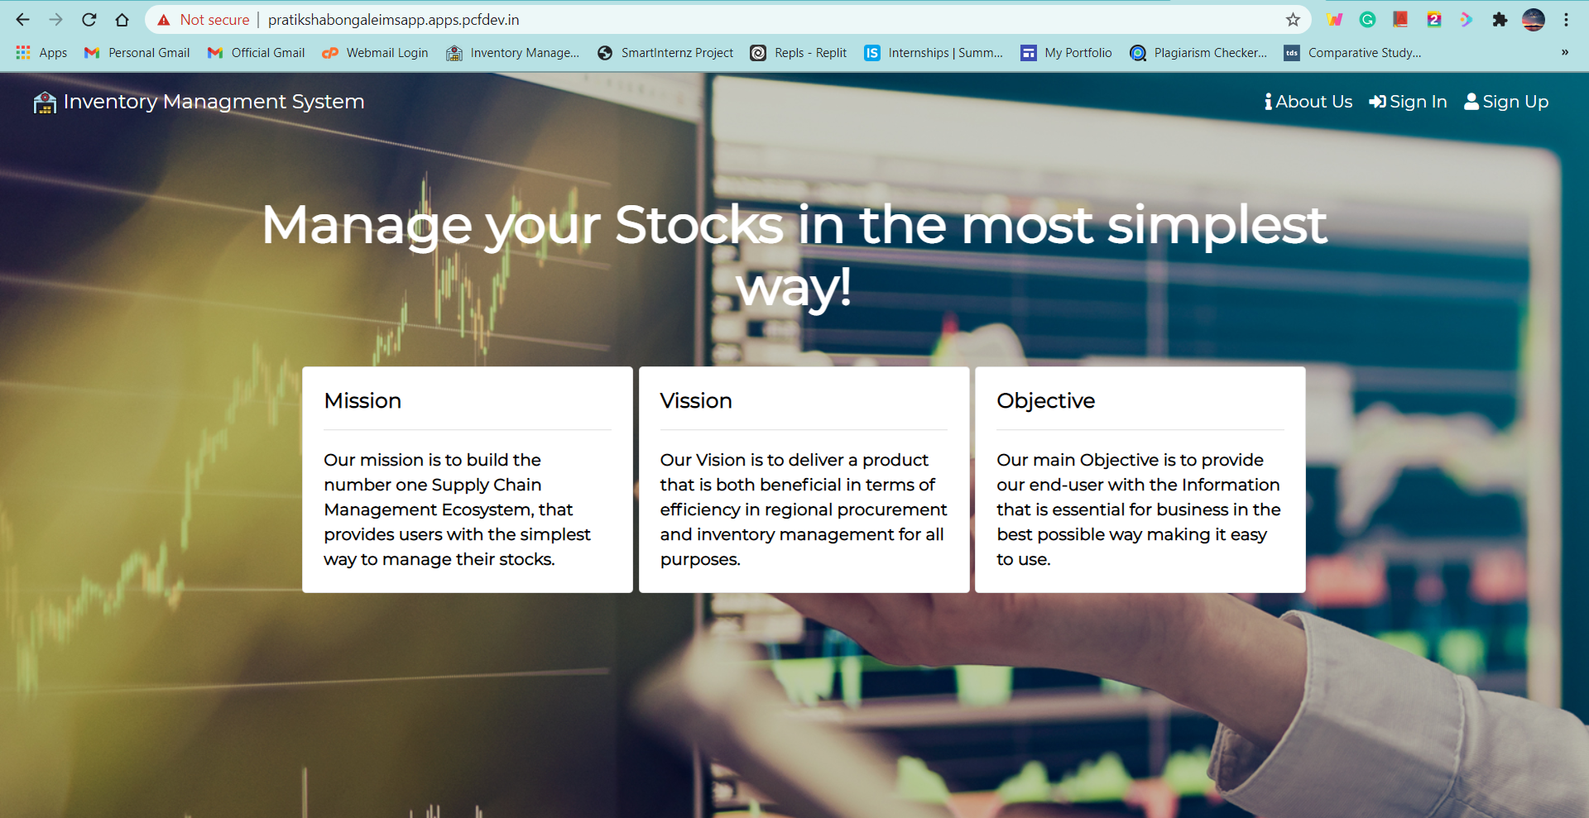

2. **About Us Page**

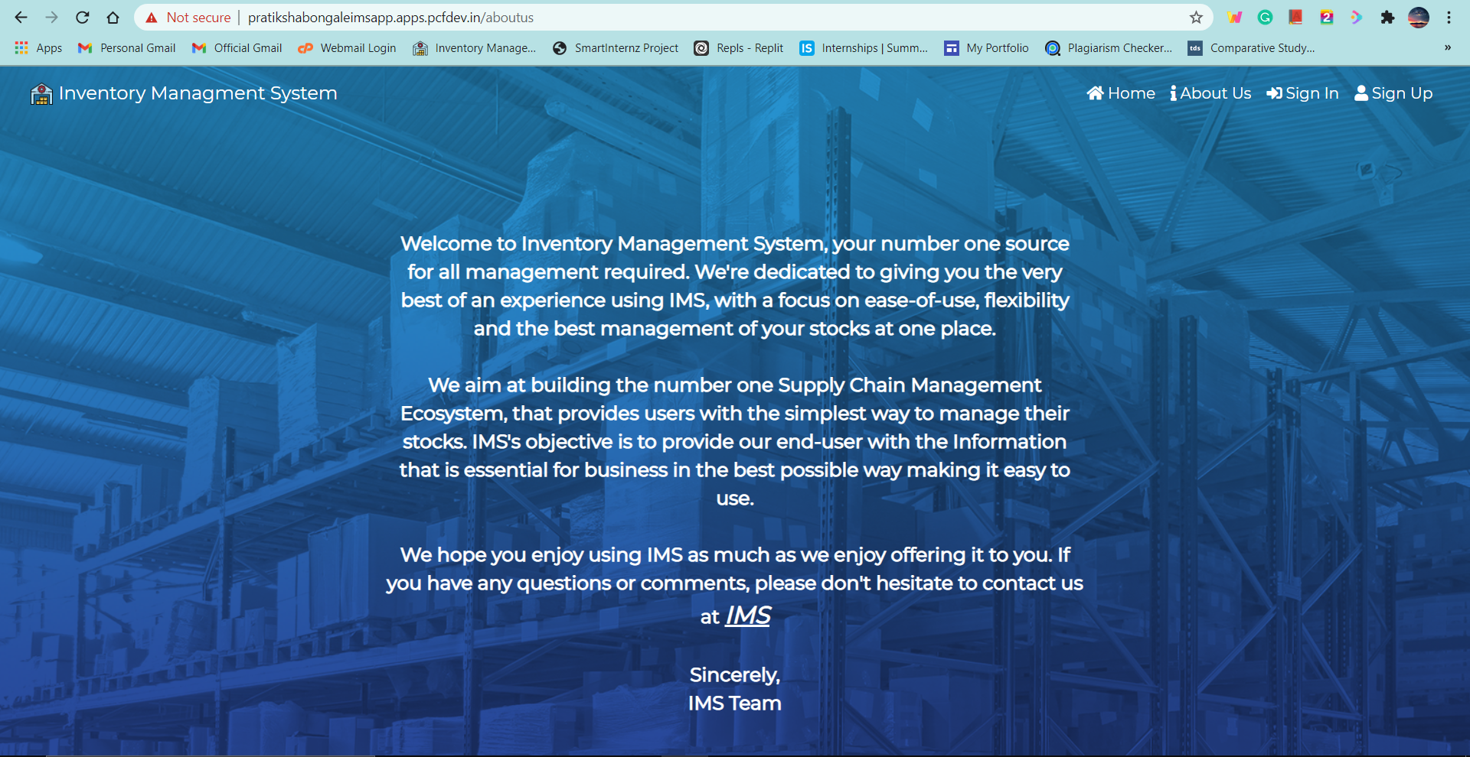

**3. Sign Up Page**

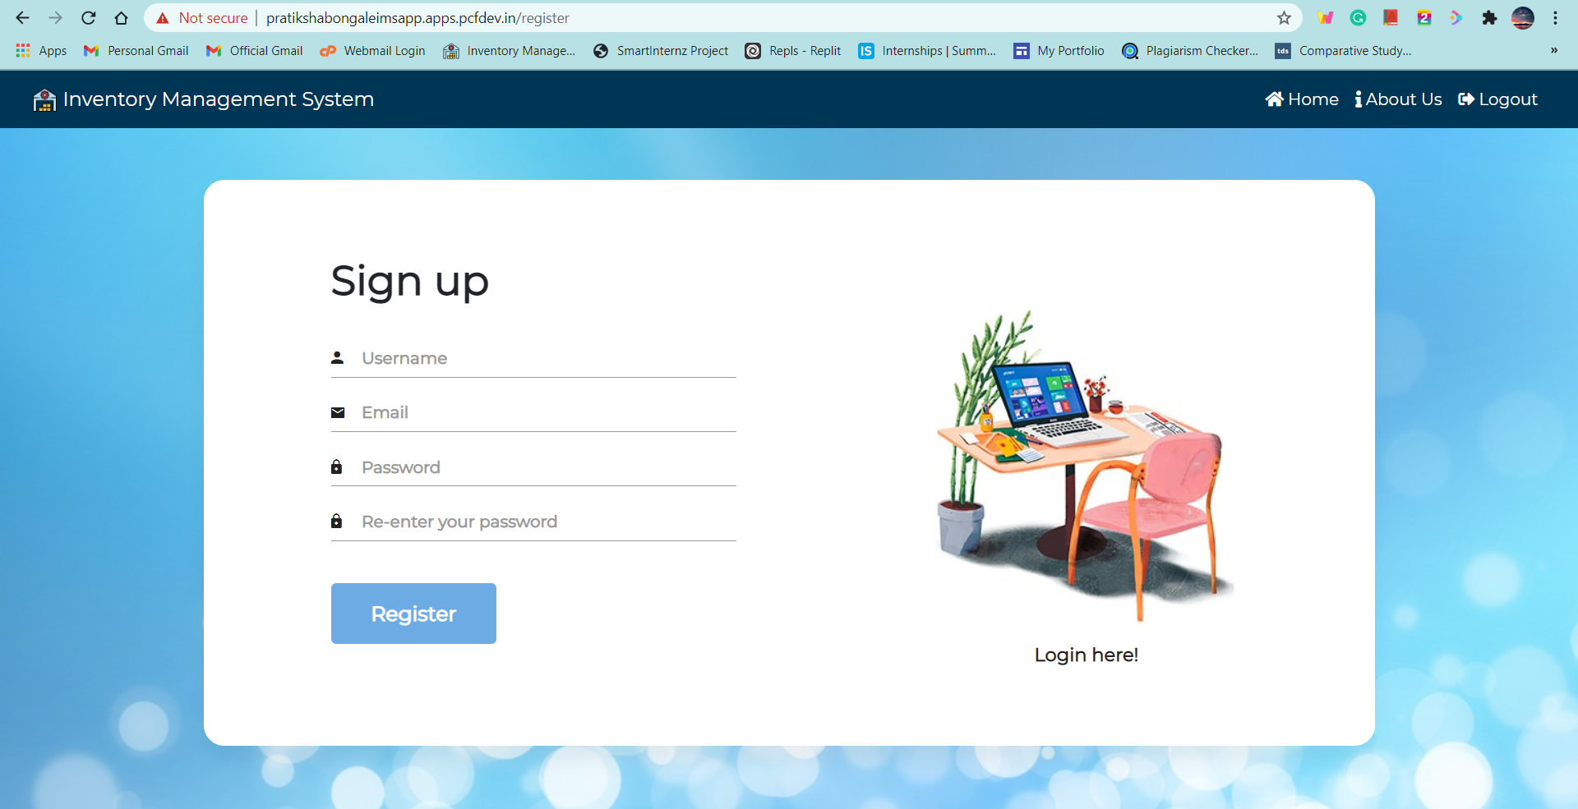

1. **Sign In Page**

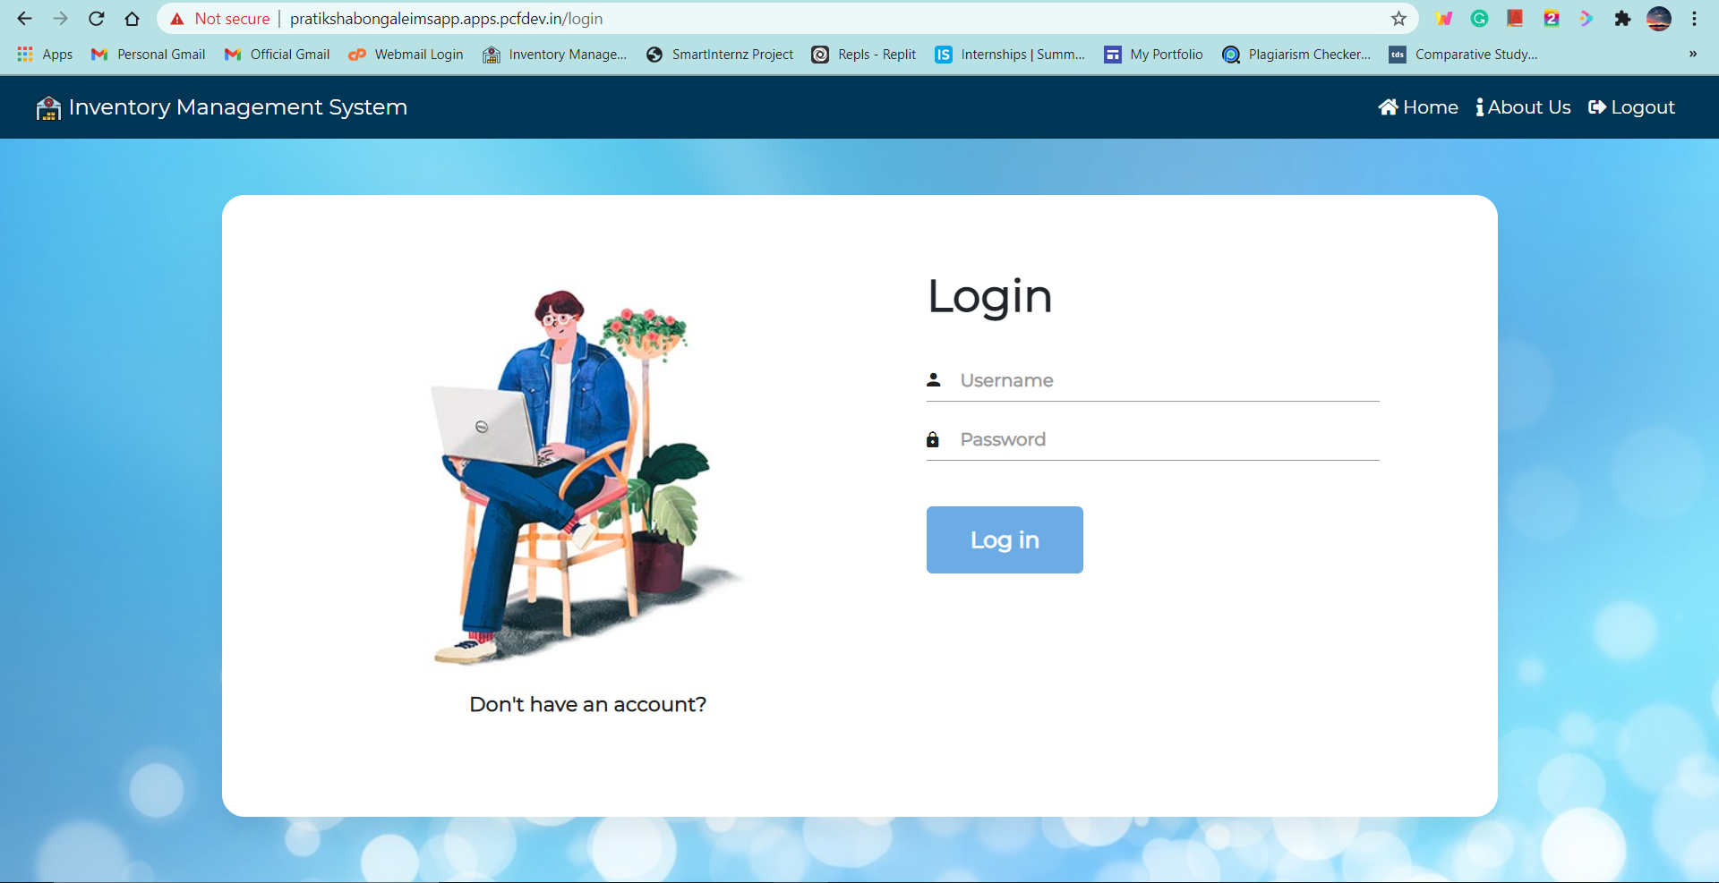

1. **Dashboard**

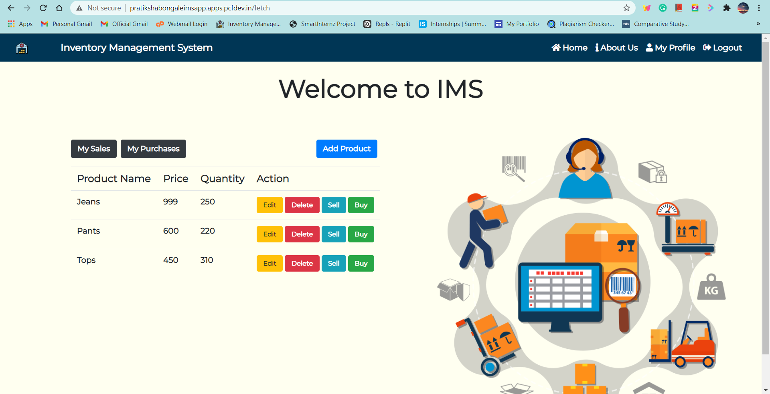

1. **My Purchases**

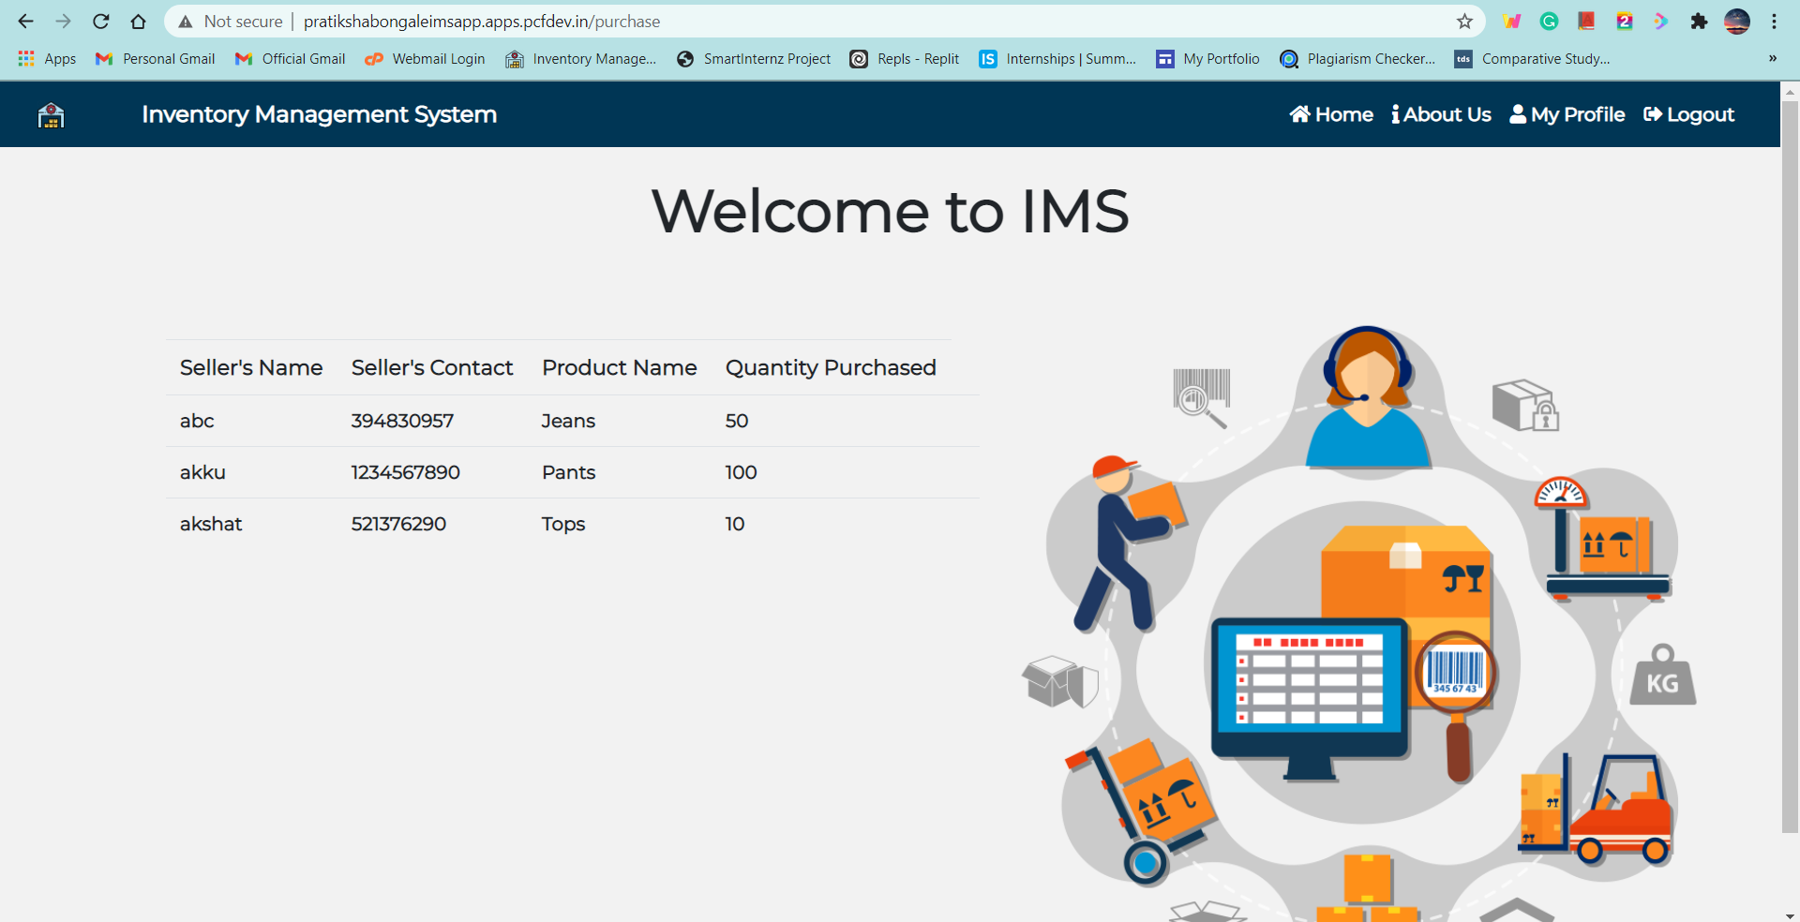

1. **My Sales**

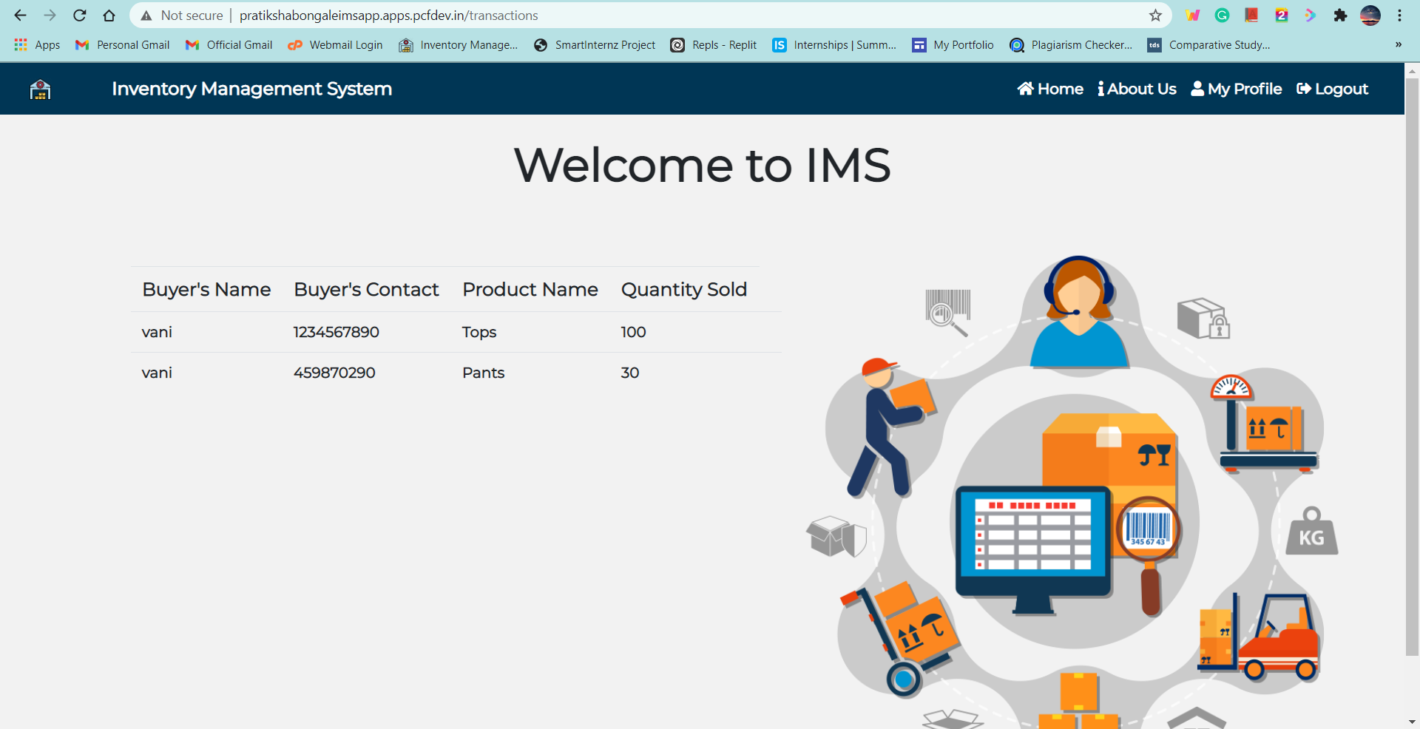

1. **My Profile**

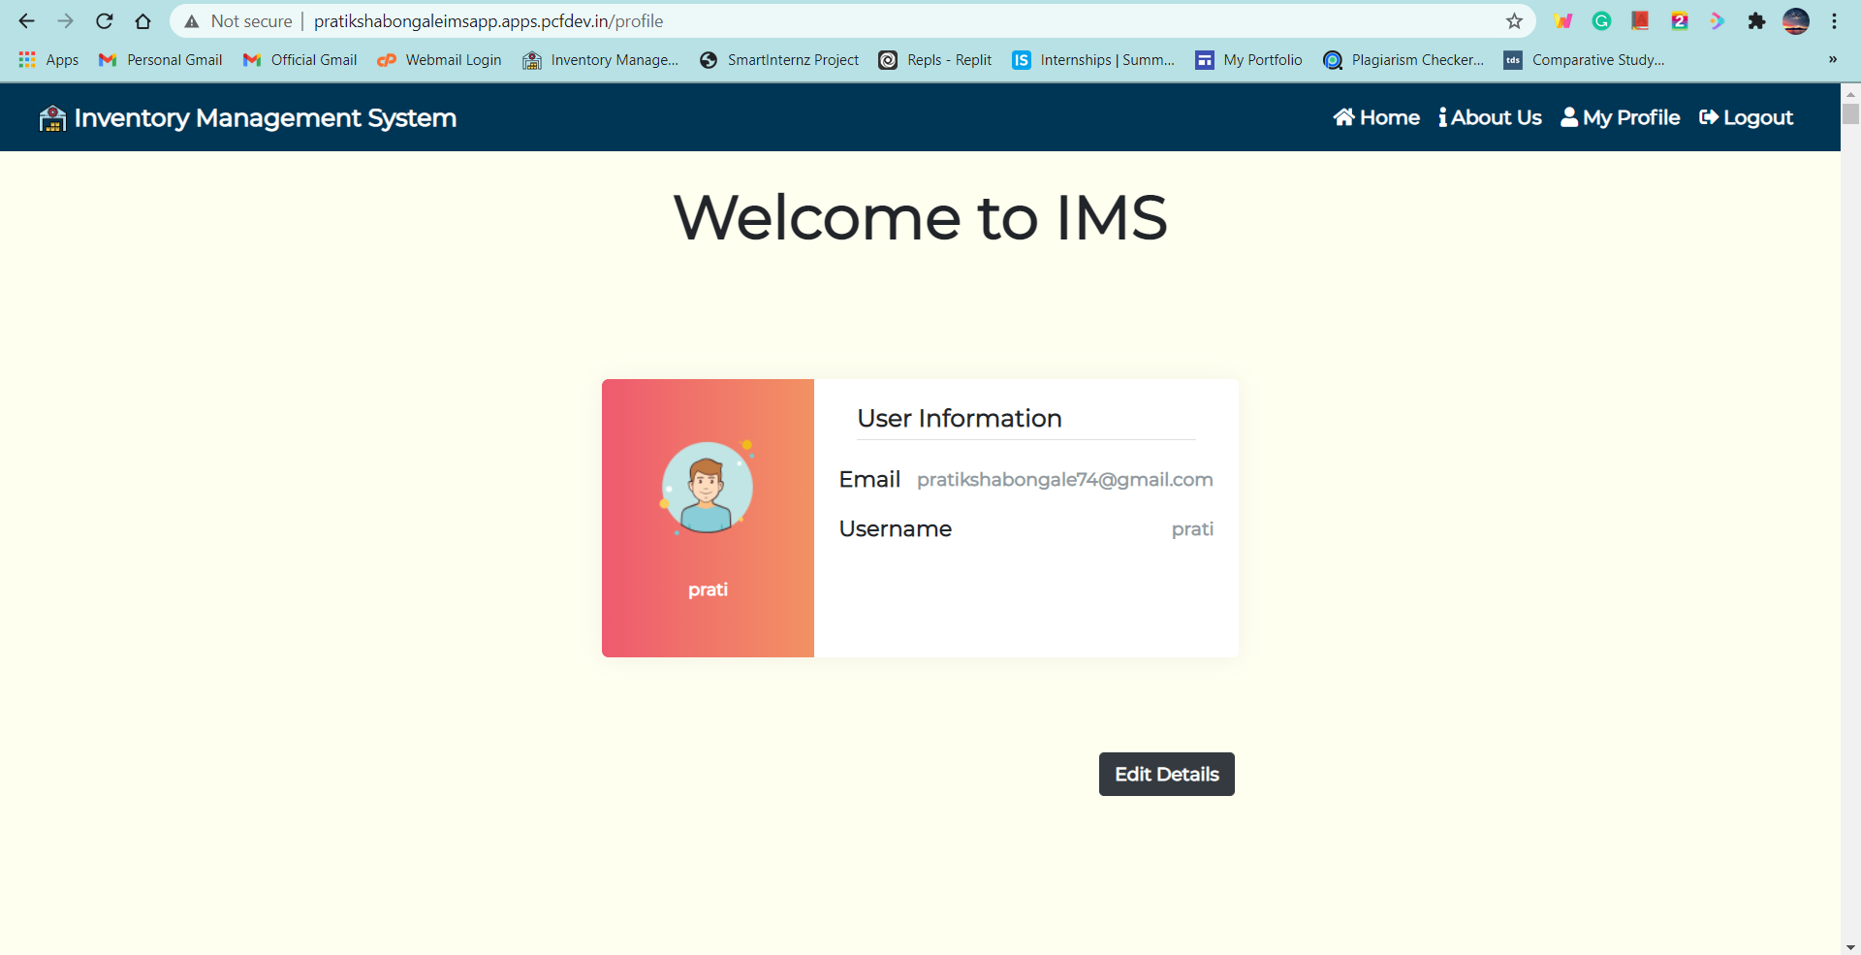

1. **Edit Profile**

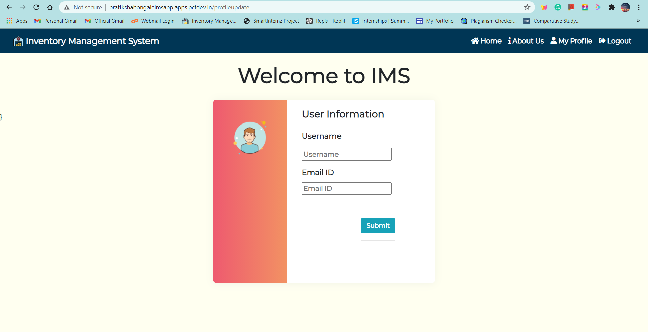

**5. ADVANTAGES AND DISADVANTAGES**

**Advantages:**

* Easy and simple User Interface for Retailers to keep track of al their inventory in one place.
* It is widely used for managing inventory in almost all the sectors that deal with customers.
* It is composed using the HTML, CSS, Bootstrap and Python for the web usage in real time.
* It can work in real time.

**Disadvantages:**

* Needs manual data enterer for maintaining the data.

**6. APPLICATIONS**

* Toyota is often considered to be the guru on lean manufacturing as they were one of the first notable names to adopt the Japanese philosophy of Kaizen in their business model. Kaizen first came about after World War Two and directly translated, it means improvement. In business, it is widely used to denote continuous improvement with lean manufacturing and waste reduction as two of its core processes
* Dell has used JIT inventory to establish themselves as a computing business which carries minimal stock and instead uses short lead times to manufacture or assemble components as and when required. The way they have achieved this is by building strong, dependable relationships with their own suppliers where they have negotiated for them to carry the stock rather than Dell. This means lead times can remain short and they have relinquished the responsibility and associated risks of carrying stock that does not have a purpose.
* In the food and beverage industry, it makes sense to implement a JIT inventory system as finished products for human consumption have a lifespan beyond which they are worthless. McDonald’s show us what this system looks like in the real world where they have components onsite for the immediate future, although nothing is assembled or made until a customer places an order. This ensures that when a customer places an order, the product is assembled in exactly the same way every time with exactly the same experienced being offered.
* This tech giant has made giant-sized steps in the direction of lean manufacturing and JIT inventory. Their motivation was not just reducing waste and associated costs but also to reduce energy consumption, ensure the energy they did consume was absolutely necessary while being renewable, and with the notion of improving their green production by partnering with the WWF and other supply chain leaders who are instrumental in China’s green transformation. So how did they do it? They established reliable and trustworthy relationships with their suppliers so that they could indeed order stock with far shorter lead times with the assurance orders would be met. They also recognised the [value of dropshipping](https://www.unleashedsoftware.com/blog/inventory-management-without-inventory-three-major-benefits-drop-shippers) where products are shipped directly from the manufacturer to the customer, cutting out ‘middlemen’ and thereby reducing shipping and storage costs.

**7. CONCLUSION**

In this system we try to build an Inventory Management System for retailers to keep track of their inventory by allowing them to insert, update, delete items and much more. It also sends them an email upon new registration and when the stock empties.A Flask application is also built for the ease of use. The app has been mordenized using docker, a docker image has been created and the same has been deployed onto vmware’s tanzu service for everyone to use.

**8. FUTURE SCOPE**

The UI can be enhanced and more features such voice instructions can be added to the system. The Inventory Management System can be powered with other warehouse operations also. Payment gateway can also be added for carrying out hassle-free online payments.

**9. BIBLIOGRAPHY**

* 1. <https://www.investopedia.com/terms/i/inventory-management.asp#:~:text=Inventory%20management%20refers%20to%20the,warehousing%20and%20processing%20such%20items>.
  2. <https://www.unleashedsoftware.com/blog/just-time-real-world-inventory-management>
  3. <https://www.unleashedsoftware.com/blog/causing-inventory-management-problems-avoid>
  4. <https://www.vinculumgroup.com/the-ultimate-5-reasons-why-you-need-inventory-management/>